UNIVERSITY OF CALIFORNIA, LOS ANGELES
CS M117

Homework #3

Students Name ___________________
HW Due 02/01/12
Section A:
1. (2) Wireless nets:
(a) What is the main similarity between a Wireless LAN and an Ad Hoc network
(b) What is the main difference?
(a)

(b)

2. (3) Why is multihopping used in Ad-Hoc nets?

Section B:
Bluetooth Communications
(T. Ch. 4. 310-317)

1). (2) From Figure 1 shown bellow; we see that a Bluetooth device can be in two piconets at the same time.

M
M
Bridge slave

Figure 1
Is there any reason why one device cannot be the master in both of them
at the same time?

2). (2) Figure 2 shows several physical layer protocols. Which of these is closest to the Bluetooth physical layer protocol?

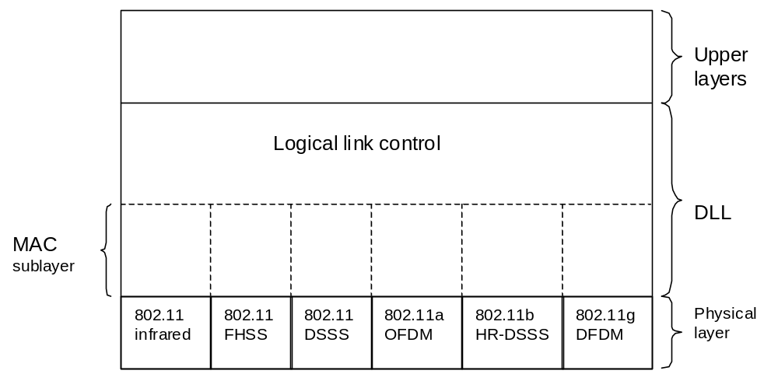
Figure 2

What is the biggest difference between the two?

3). (3) Beacon frame in the frequency hopping spread spectrum variant of 802.11 contain the dwell time, Do you think the analogous beacon frame in Bluetooth also contain the dwell time? Discuss your answer.

4) (3) (a) List the three different modes of signal propagation (besides direct signal) and the cause for each of these modes.
(b) What kind of signal reception problems these different modes cause?
a)

b)

5) (4) (a) How do multipath signals effect signal reception? This effect limits
the transmission rate of wireless channel.
(b) Give relation between transmission rate and this “effect“ in part (a).
a)

b)

6) (1) What is frequency range of Bluetooth Channel?

